# 2nd Testing – 12th April

Story 6: Upload a file: file explorer

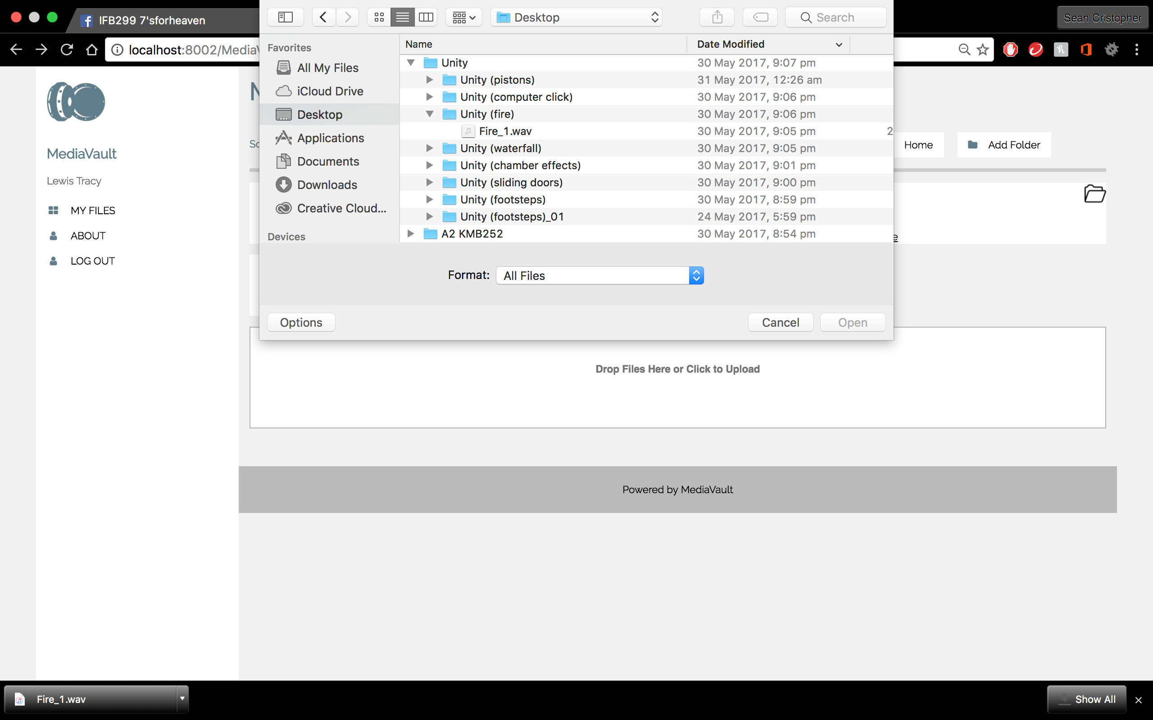 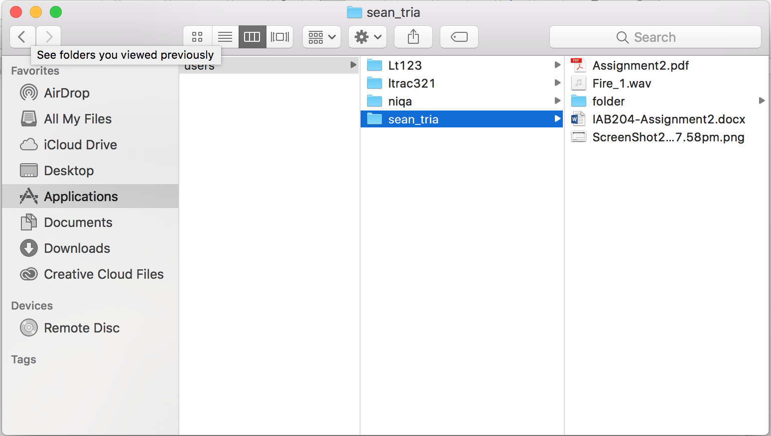

* Empty grid below functions as a button for file explorer for upload
* Test shows upload feature functions
* Test confirms the right file uploaded is on the grid after the page is manually refreshed

Story 6B: Upload a file: Drag and drop

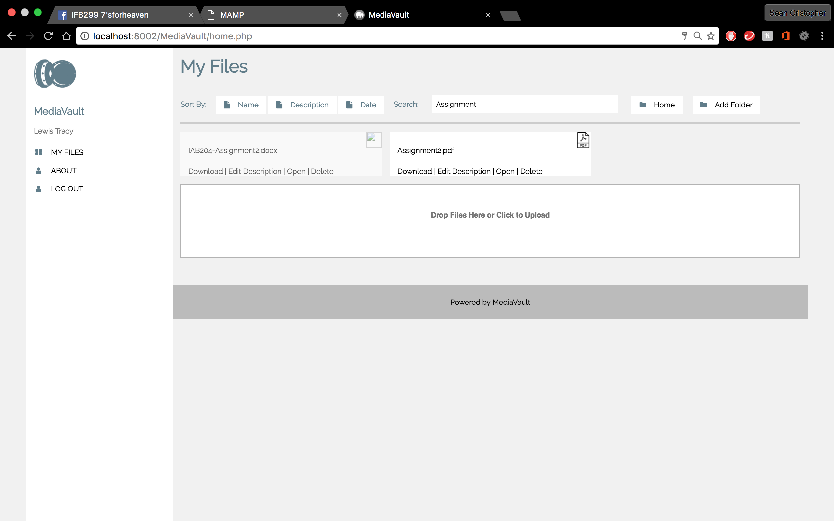 

* Empty grid below functions as a layout for drag and drop
* Files successfully uploads to file server just like file explorer after the page is manually refreshed

Story 5: Download my File

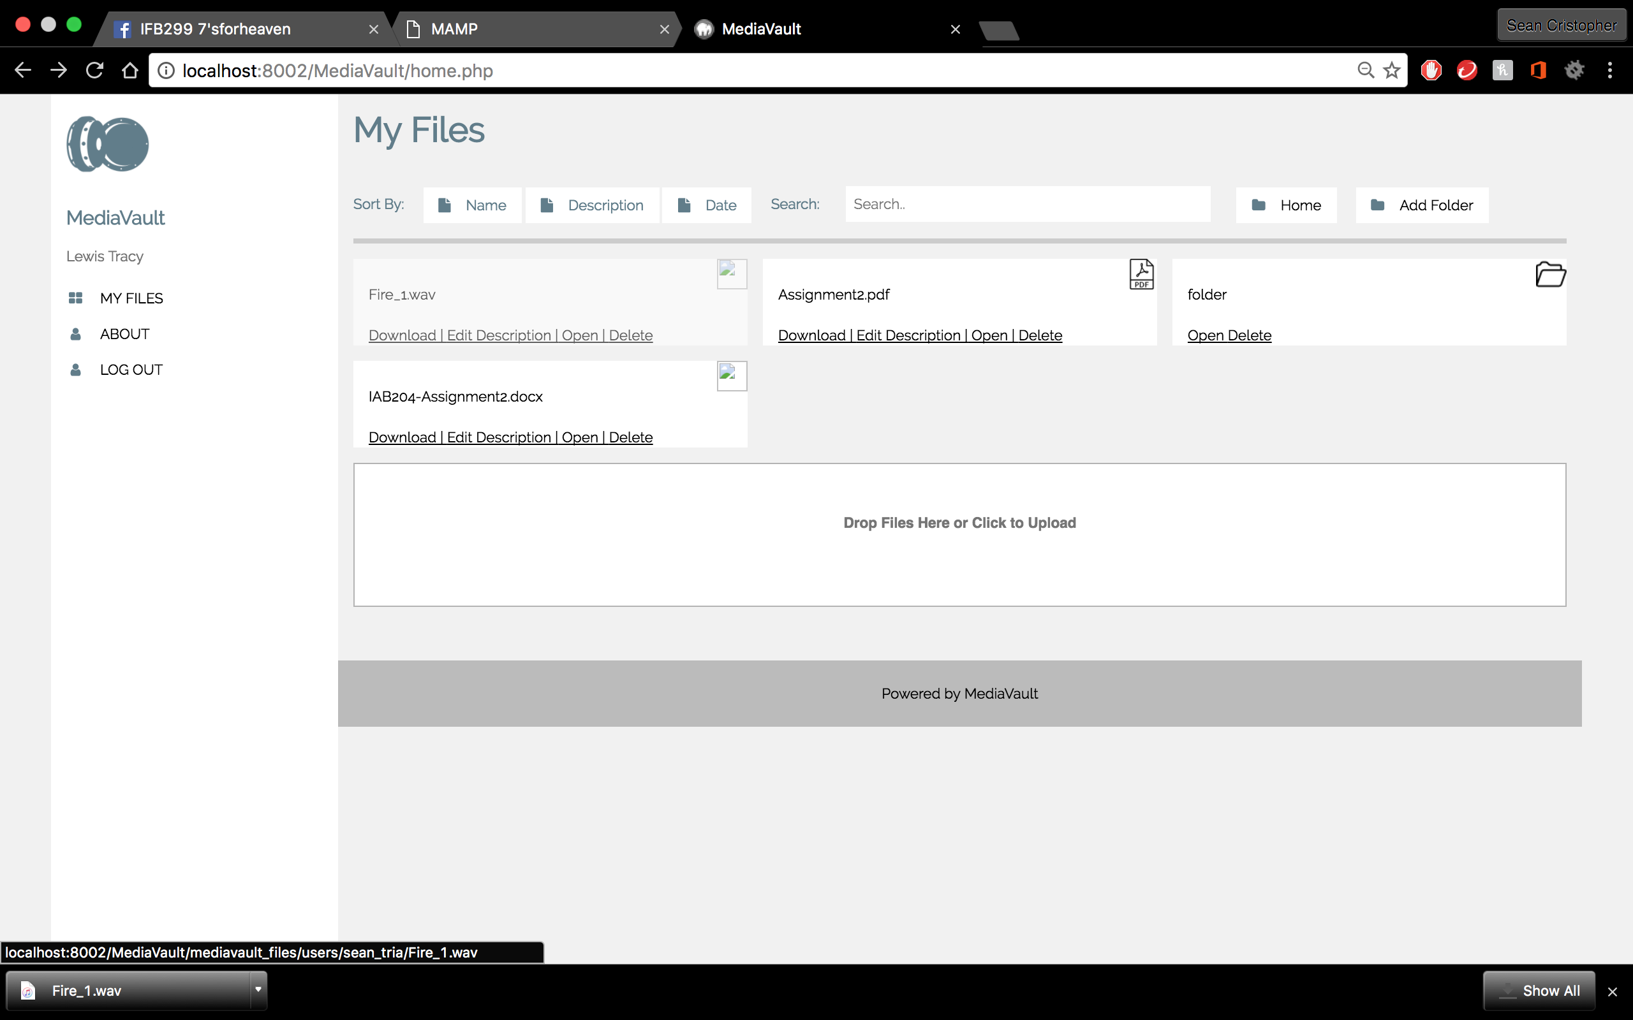

* Download button is independent for each file and functions when clicked
* Test shows the right file is downloaded

Summary: Second testing completed. User stories functions. Refreshing the page manually is required to view uploaded files. Upload speed is slow.